Colstrip Parks & Recreation District
Fall 2026
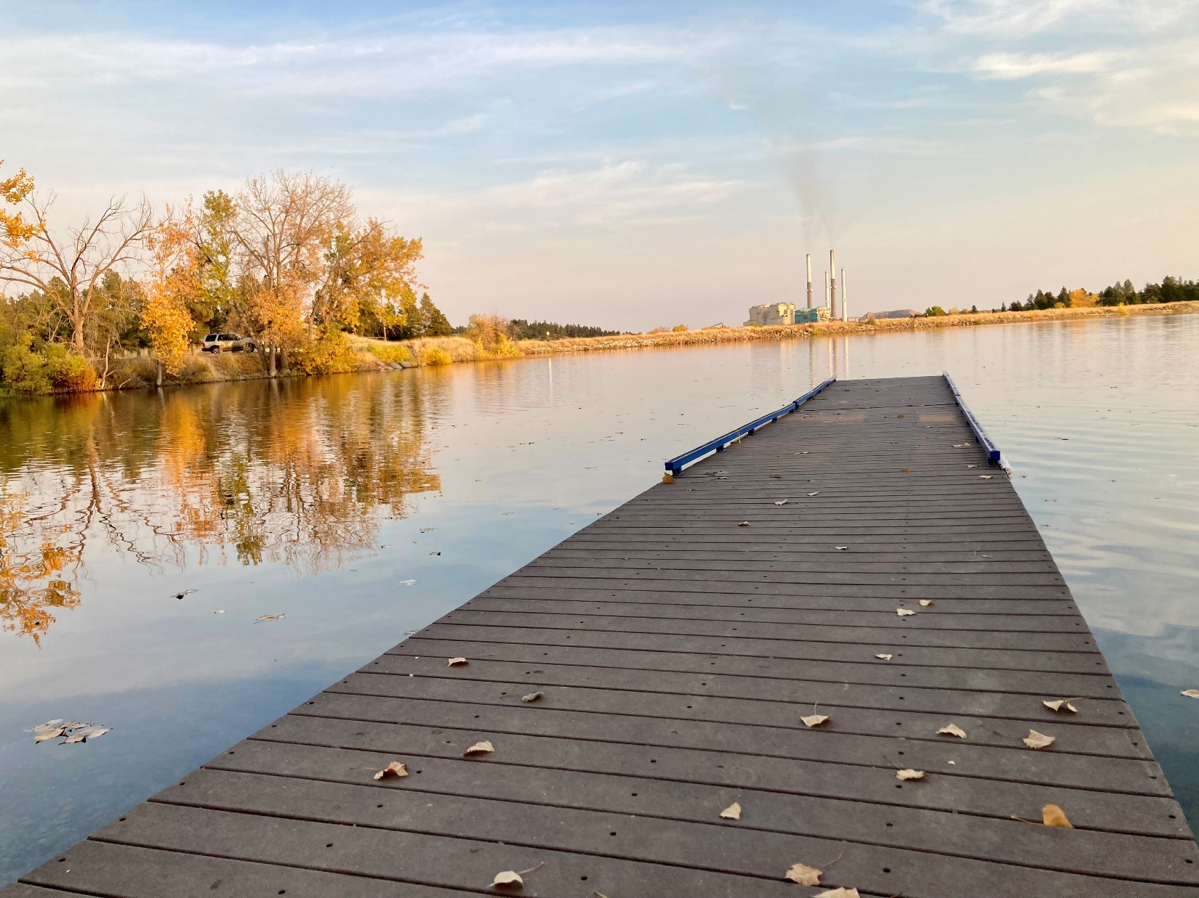

Facility Hours
Monday—Thursday
4:00 AM – 9:00 PM
Friday
4:00 AM – 7:00 PM
Saturday & Sunday
8:00 AM – 3:00 PM
Contact Information
110 Park Street
PO Box 127
Colstrip, MT 59323

Phone: (406) 748-3326
Fax: (406) 748-2426

cprdinfo@colstripparks.com
colstripparks.com
Facebook: Colstrip Parks

Open Gym Hours

High School & Middle School

Friday 7 PM — 9 PM

Fall Classes Begin
September 8th

Cover photo courtesy of Tana Pippin

Staff Members
Liz Jensen
Executive Director
Leslie Neiss
Payroll/AP Clerk
Tasha Miller
Programs/Fitness Superintendent/Pool Supervisor
Karri Kerzmann
Office Manager/Breakfast Club/Nursery Supervisor
Korilee Willard
Afterschool Program/Summer Programs Supervisor
Sierra West
Child Care Supervisor
Suzy Batie
Golf Course Superintendent
Joey Gillespie
Pro Shop Manager
Markus Arneson
Building Maintenance
Chevi Hage
Parks Superintendent

Board Members
Garrick Goodheart
Jerry Gillespie
Gary Lovato
Bill Neumiller
Gary Parry
Joette Speake
Front Desk
Karri Kerzmann
Joey Gillespie
Kaylee Harrison
Amie Gruel
Malesha Siegel
Morgan McManus
Ashleigh Zuehlsdorff
Paulette Yurian
Freyja Briggs

Fitness Instructors
Tasha Miller
Renee Hofacker
Janelu Hossner
Nickolas Parker
Amie Gruel
Stephanie Scarber
Jessica Howell

Facility Numbers
Administration/Recreation Center
(406) 748-3326
Ponderosa Butte Golf Course
(406) 748-2700

Registration & Refund Policy
All registrations must be in person. No phone, mail, or email registrations. All class fees must be paid in full at the time of registration. Absolutely no refunds or credits will be given for any class unless CPRD cancels a class due to lack of participation.

Fitness Classes Begin September 8th

Last Day of Fitness Classes: December 18th

CPRD Youth Zone
Programs for Every Age and Stage

Nursery

CPRD’s Nursery offers a safe, fun, and nurturing environment for your babies and kids while you get in your workout. We have toys for playtime and other fun activities. We require immunization records to be on file to keep everyone healthy. Enjoy your workout worry free!
Please have bags and sippy cups marked with your child’s name.

Staff: Sierra, Kori, Kim, Callie, Kenzie, and Macie
Day Nursery Hours:
Monday – Thursday 9 AM – 12 PM
Friday 9AM – 11 AM
Evening Hours
Tuesday & Thursday 5 – 7 PM
Monday Volleyball Nursery Hours
6:30 – 9 PM while you are playing!
*Hours are subject to change.
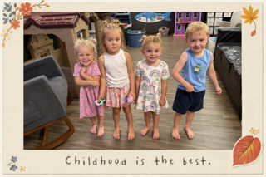

Rise Gymnastics

Calling all energetic 4- and 5-year-olds! Join us for a fun, encouraging introduction to gymnastics where young athletes will build confidence, learn foundational gymnastics skills, practice flexibility, and strength, and most importantly have FUN! Spots are limited to 12.
When: Mondays 10:00 AM – 10:45 AM
Wednesdays 10:00 AM – 10:30 AM
Led by: Tiana Yates
Cost: Members Free
Non-Members: $10 per child, per session

Tot Time
Looking for a fun class where your little one can run, play, dance, and sing? Join Tasha on Wednesdays in the big gym for Tot Time! It’s the perfect space for kids to play and make new friends! Ages 3–5.
When: Wednesdays 10:30 AM – 11:00 AM
Led by: Tasha Miller
Cost: Members Free
Non-Members: $10 per child, per session

Supervision Policy
Our policy requires that no child under the age of 9 will be allowed in the building without the direct supervision of a person 13 years of age or older.
Open Gym

Shoot some hoops, play a little volleyball, or just hang out with friends at teen night! Middle School & High School students only.

When: Fridays 7 –9 PM
Location: CPRD Gym

Fall Youth Sports
Youth Soccer returns this fall! Watch our Facebook page for Utah Jazz Basketball registration dates and program details.

Breakfast Club
Looking for a safe space for your child to go to before school in the morning? Bring them to Breakfast Club! Breakfast Club is open at 6 am every morning that school is in session. Transportation to school is provided. While at the program, children may receive help with homework, spend time playing games, or participate in other activities!
Supervisor: Miralga
Staff: McKenzie & Melissa
When: Monday — Friday 6:00 AM – 8:00 AM
Every day that school is in session.
Cost: Free

Where: CPRD Community Center


Afterschool Program
CPRD Kids is an afternoon program offering caring adult supervision for the children of out-of-the-home working parents. We provide children, kindergarten through 5th grade, a place to go after school. We offer help with homework, games, arts and crafts, snacks, and many other fun activities! Any further questions, please contact Korilee at (406)748-3326 ext. 126 or the after-school programs cell number (406)740-2322.
Supervisor: Korilee
Staff: Kim, Sierra, Callie, Miralga, & Joe
Cost: $50 per quarter
Quarter starts: Q2 Oct. 22 • Q3 Jan. 14 • Q4 Mar. 18
When: Monday — Thursday 3:30 PM–6:00 PM
Fridays 2:30 PM–6:00 PM
Every day that school is in session.
Where: CPRD Community Center

Your Fitness Journey Starts Here

Together, let’s build a plan that works for you.

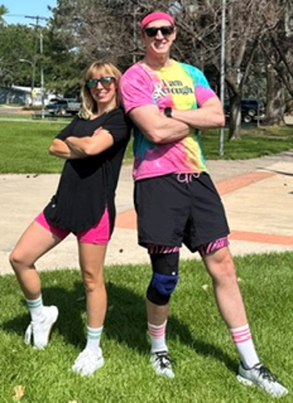  Meet Your Trainers  Nickolas & Renee  AFAA-Certified Personal Trainers  Whether you’re just getting started or reaching your next goal, we’re here to help. | Fitness for Real Life  Fitness isn’t just about pushing limits—it’s about building a body that feels strong, capable, and resilient for real life. We are both AFAA certified personal trainers who help clients achieve their fitness goals through custom exercise programs and guidance.  Whatever your goals, we’ve got your back! If you want to gain strength after injury or health setbacks, accelerate athletic performance, or have the classic need to manage weight and get in shape, we can meet you exactly where you are right now while challenging you to grow.  Fitness should promote all aspects of well-being, adding fun to your routine and fueling your zest for life. Give us a call to schedule an initial consultation—free for members $25 for nonmembers!  How We Can Help  - Personalized plans & feedback  - Strength and conditioning  - Balance and mobility  - Accountability and encouragement  - All levels welcome: Beginner to Advanced

Ready to Get Started?
Call Nickolas or Renee at (406) 748-3326, ext.121
to schedule an appointment.
Initial Consultation  Members: Free  Non-members: $25 | Personal Training  Members: $30/hour  Non-members: $35/hour  After the initial consultation



CPRD Fitness Classes
Discover Your Strength, Inside and Out.

Weightlifting
This class works all your major muscle groups using proven weight-room exercises. With a focus on safety and proper technique, you’ll learn the fundamentals of weight training, so you feel confident lifting in class and on your own. Class size is limited to 16—please arrive early to secure your spot!
Instructors:
Renee Mondays & Wednesdays
Nickolas Fridays
Location: Weight Room
When: 9-10 AM M, W, & F

Group Power
Join Janelu for a one-hour, cutting-edge strength workout using adjustable barbells, weights, a step, and your body weight. This class blends traditional strength training with fresh, innovative moves to keep it fun. Heart-pounding music and expert coaching will take your fitness to the next level!

Instructor: Janelu
Location: Fitness Gym
When: 9-10 AM M & W
Zumba
If you have not joined us yet, you are missing out! It is a fun, effective, easy-to-follow Latin dance party. All levels are welcome—come dance with Janelu and get a great workout without even realizing it!
Instructor: Janelu
Location: Fitness Gym
When: 10-10:45 AM M & W
10-10:30 AM F

Tai Chi
Tai Chi is a beautiful martial art that has shown that it can improve cardiovascular health, enhance balance, flexibility, boost cognitive function, reduce anxiety, and even support quality sleep patterns. This class will be the calm center of your turbulent modern existence.

Instructor: Nickolas
Location: Fitness Gym or outdoors in the park
When: 11-11:30 AM M & W
October Evening Pop-Ups
Watch Facebook for details!

Lunch Lift
Lift weights and your spirits during this action-packed lunch hour! Fun, scientifically designed workouts will leave you tired yet hungry for more.
Instructor: Nickolas
Location: Weight Room
When: 12:10-12:50 pm M & W

Spin to Win
Spin your wheels amd win the prize of superior cardio performance. A combination of killer music, lights, and (some) choreography will transport you to a world of fun even though you are technically stationary.
Instructor: Nickolas
Location: Fitness Gym
Time: 9 AM- 9:45 AM T & TH
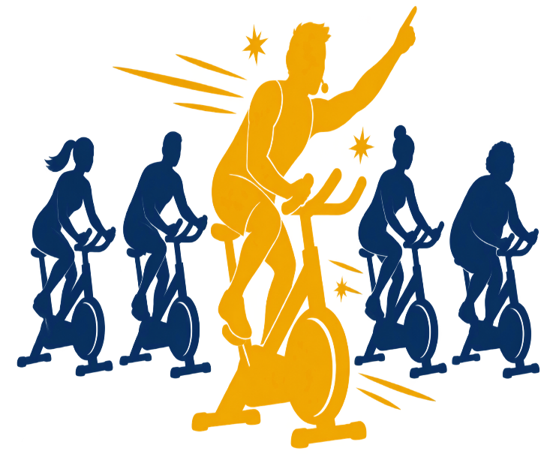
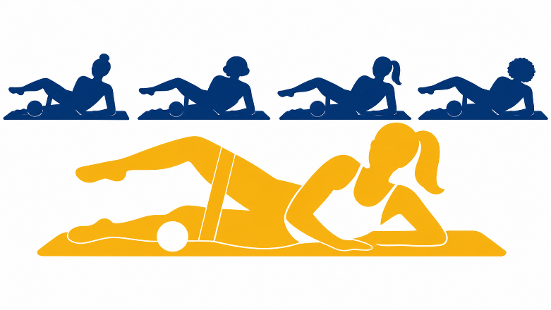
Barre
Barre is a low impact workout that blends movement from ballet, Pilates, yoga, and resistance training. Each class focuses on improving posture, core stability, and muscular endurance all to the beat of the music. Get ready to plié your way to a stronger and more powerful you!
Instructor: Renee
Location: Fitness Gym
When: 10 AM - 11 AM T & TH

Fun and Functional
You cannot spell functional without fun! Groove to cool tunes while exploring activities that stimulate balance, hand/eye coordination, mobility, and strength. All ability levels and ages welcome.
Instructor: Nickolas
Location: Fitness Gym
When: 11-11:30 AM Tuesdays Only
Returns in October!

Gentle Stretch
This class is designed for a series of gentle stretches in a chair or standing. Ease tension and relax with friends. Perfect for all levels.
Instructor: Amie
Location: Fitness Gym
When: 11 AM- 11:30 AM Thursdays
Returning in October!

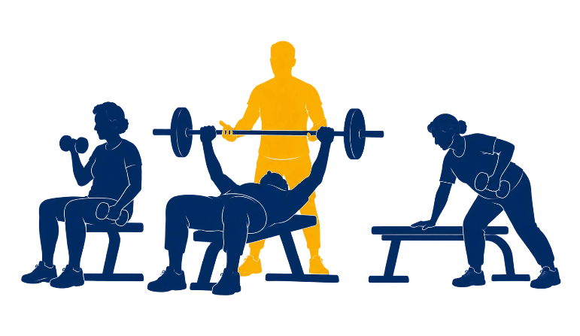

Senior Strength
This senior focused strength class combines low impact exercises to improve balance and increase mobility, fueling a vibrant lifestyle at any age!
Instructor: Nickolas
Location: Fitness Gym
When: 1 PM – 2 PM T & TH
Uplifting Evening
Hit the gym for a little pick me up after work. This periodized approach to full body resistance training is perfect for people who need to get a lot done in a short amount of time!
Instructor: Nickolas
Location: Weight Room
When: 5:15 PM – 6 PM T & TH

Cathartic Cardio
Balance aggression and meditation in this kickboxing cardio class. Build confidence and release negative emotions in a safe environment open to all fitness levels. Take heart and kick butt!
Instructor: Nickolas
Location: Fitness Gym
When: 6:15 PM - 7 PM T & TH
Pickleball
Grab a paddle and jump in—pickleball is a quick, social game that’s great for cardio, coordination, and friendly competition. Beginners and seasoned players are welcome!
Group Therapy
Location: Pickleball Courts or Gym
When: 6 PM – 8 PM Tuesdays
10 AM – 11 AM Fridays

We are committed to providing a safe space and positive environment for all members and guests at CPRD. As a minor (13-17) your child is required to complete a signed waiver and understand the established rules for using the facilities. Please read the rules carefully with your child, sign and return the waiver to the front desk.

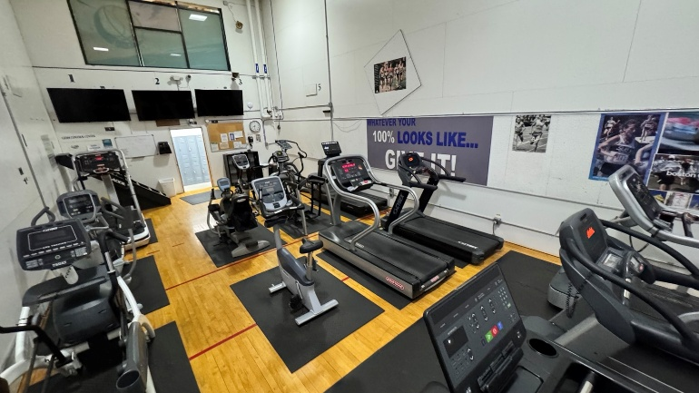
Heart Healthy Cardio Room

As the days get cooler, bring your workout indoors! The Heart Healthy Cardio Room has a variety of equipment for a quick workout, steady training, or keeping up with your regular routine. Whether you’ve got 20 minutes or a full hour, you can set your pace, hit your goals, and leave feeling energized.
Take a Ride!
Our Peloton bike is located upstairs in the Fitness Gym and is available for members to use whenever classes are not in session.

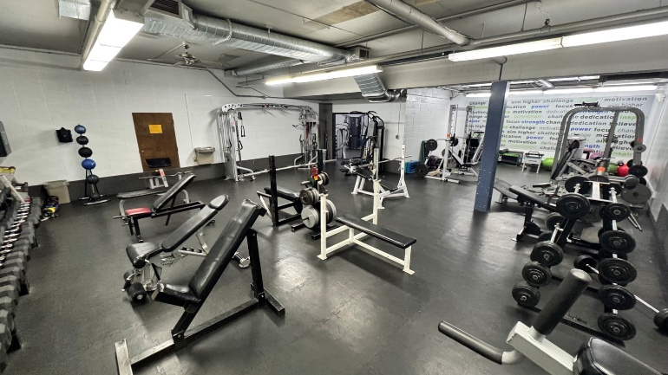

Expansive Weight Room
Keep your lifting routine going this fall in our weight room. Whether you’re just starting out or you’ve been lifting for years, it’s a great place to work on form, stay consistent, and get a solid workout in. Must be 18+ to use the saunas.

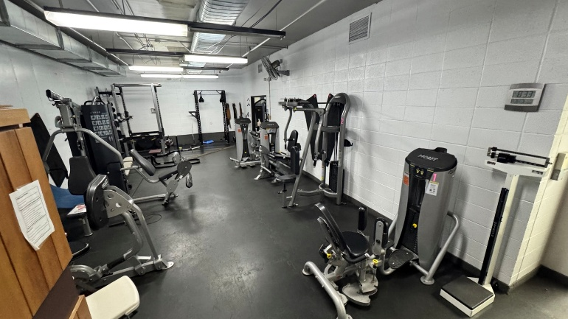


Monday Night Ladies Volleyball  Register your team or join one and come play Monday night volleyball! Enjoy six weeks of games followed by two weeks of tournament play, with plenty of friendly competition, laughter, and social time along the way.  When: 6:30 PM Mondays  Location: CPRD Gym  Round Robin/Registration: Monday September 14th  Cost: $30 | Ponderosa Butte Golf Course  The golf season may be winding down, but there’s still time to enjoy a few more rounds at Ponderosa Butte Golf Course before the snow flies! For course updates, hours, and more information, visit our website at ponderosabuttegolfcourse.com or on Facebook at The Ponderosa Butte Golf Course.
Fall Fitness Schedule
Time | Monday &  Wednesday | Tuesday &  Thursday | Friday
9:00 AM | Weightlifting /  Group Power | Spin to Win | Weightlifting
10:00 AM | Zumba | Barre | Zumba (30 min.)  Pickleball
11:00 AM | Tai Chi | Tue: Fun & Functional  Thu: Gentle Stretch
12:10 PM | Lunch Lift
1:00 PM |  | Senior Strength
5:15 PM |  | Uplifting Evening
6:00 PM |  | Pickleball
6:15 PM |  | Cathartic Cardio
Fall Fun Pop-Ups
Watch Facebook for dates and details!

